SBS unveils refugee and asylum-seeker dramas for 2017 as Viceland launches

Shows include Sunshine, about South Sudanese refugees in Melbourne, and Safe Harbour a thriller about when asylum seekers meet holidaymakers.

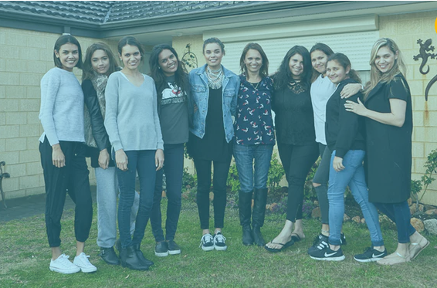

SBS channel NITV has a new local production called Family Rules, a reality show about an Indigenous family. Photograph: SBS

Two topical new dramas exploring the refugee and asylum-seeker experience in Australia and new documentaries putting racism and poverty under the spotlight headline SBS’s TV offering for 2017.
After facing some criticism for drifting away from its multicultural charter, the channel’s new schedule appears to put a renewed focus on providing diverse and unique content viewers won’t find on commercial channels.
Along with a second series of the controversial documentary Struggle Street, a new program hosted by Ray Martin, I’m Not Racist, But…, will use hidden cameras to reveal the worst of Australian attitudes towards those of non-Anglo background.

Former SBS newsreader Indira Naidoo is returning to the network as host of a local version of BBC format Filthy Rich and Homeless, which takes a wealthy family and puts it on the street to experience homelessness.

Roy & HG’s Greig Pickhaver is hosting Hidden History of our Suburbs, a series which reveals the country’s immigrant past in the suburbs. Another show The Mosque will delve into the importance of the mosque in the Australian community.

The rich slate of local content was unveiled on Tuesday before the switch was flicked on SBS Viceland, a new channel consisting of content from SBS2 as well as programs from the global youth brand Vice. Popular shows from SBS2 like The Feed and the Chinese dating show If You Are the One are moving to SBS Viceland. SBS2, which launched as a youth channel three years ago, was turned off on Tuesday at 4pm.
The managing director of SBS, Michael Ebeid, said the partnership between SBS and US media brand Vice was perfect for the network’s multicultural channel with its commitment to diversity.

Behind the titles are some provocative, informative and serious programs
Michael Ebeid, SBS managing director

“I think it’s a great fit,” he told Guardian Australia. “It will help us engage with a demographic that doesn’t traditionally engage with SBS. If you look at the provocative titles alone you are going to say ‘what the hell’ but they are there to attract a difficult-to-reach audience and behind the titles are some provocative, informative and serious programs.”

“If you ask people in their 20s and 30s they know Vice and it’s a great brand. If you look at the Vice charter it’s all about helping young people to understand the world that they live in, understand the cultures around the world. That’s what we do.”
The cheeky titles which have everyone talking are Weediquette (about the culture of marijuana), F*ck, That’s Delicious (a rapper who travels the world in search of great food) and Balls Deep ( living with an unfamiliar culture).
As well as a second series of The Family Law SBS is offering two new local dramas next year, a strong haul for a network with a relatively small budget for local content.

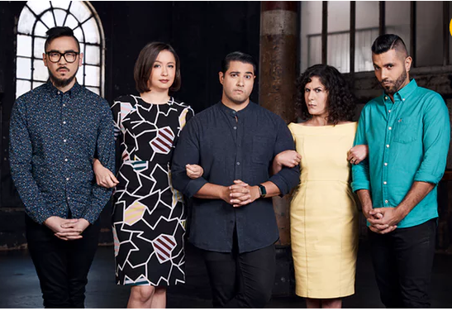

Sunshine is about South Sudanese refugees living in Melbourne and the drama centres on a young basketball player accused of assault.

Safe Harbour is a psychological thriller about the crossover between a group of asylum seekers trying to get to Australia and local holidaymakers on a boat.
SBS has four channels: SBS, SBS Viceland, The Food Network and NITV, plus a catch-up TV platform SBS on Demand.

NITV has a new local production Family Rules, a reality show about an Indigenous family as well as its first animated children’s TV show featuring Indigenous actors Miranda Tapsell, Deborah Mailman, Ningali Lawford and Aaron Fa’aoso.
Viceland’s international president, Jay Rosenstock, out from New York for the launch, said the content for the Australian edition of Viceland would be no different to that shown in the US and Canada or in the UK, all which launched channels this year.
“We really produce with an eye to taking the content globally,” Rosenstock told Guardian Australia. “We look at it with the same creative eye as we do for the US and the UK.
“I came out of Discovery where we produced a lot out of the US and sent it around the world. Our Viceland content model is kind of Discovery on steroids. We produce it all around the world and send it all around the world. Our youth focus gives us broader brand permission to create content in different places.”
The international dramas to screen next year include a new series of Fargo, Vikings and Knightfall.

